Traffic Sign Classification

Authors:
Megan Joseph, Siling Guo, Anna Wadlow, An Truong, Robert Yav

Abstract
Autonomous vehicles are becoming increasingly more common as technology advances. It is only natural to explore how different aspects of them work. Our focus will be on traffic sign classification using traditional machine learning techniques. To investigate this, we use the LISA Traffic Sign Dataset containing over 6000 images of traffic signs. We then convert the images to grayscale, and resize, flip, and rotate them. The data reduction techniques we use are principal component analysis (PCA) and uniform manifold approximation and projection (UMAP), and we use t-distributed stochastic neighbor embedding for data visualization (t-SNE). After applying the train/test split with synthetic minority oversampling technique (SMOTE), we applied the classification methods random forest, extreme gradient boosting, support vector machine, and naive bayes. We found that PCA and SVM performed the best with a balanced accuracy of 0.975 and a macro-F1 score of 0.972. Across the board, random forest performed the best while naive bayes performed the worst, as expected. In the future, we would like to hyperparameter tune each classifier to get the best performance and try deep learning approaches.

Problem Description and Importance
Given a real world traffic situation, how can computers identify and perform the correct actions in order to safely mimic a human's decision making? An important initial step in this problem is correctly identifying the traffic signs themselves. This project aimed to classify a set of traffic sign images using different data visualization, data dimensionality reduction, and classification techniques. This particular application of computer vision is especially important in the realm of autonomous self-driving cars. This would be a preliminary step that engineers would take from companies like Tesla and Waymo, linking real world vision with classical data dimensionality reduction and visualization techniques. Additionally, increasing the classification accuracy of algorithms controlling autonomous vehicles is a crucial necessity in proving the safety of these emerging technologies. Previous approaches for classifying this type of data primarily use deep learning, particularly Convolutional Neural Networks (CNNs) and pretrained models. Since these methods go beyond the scope of our class, we stick to more classical machine learning techniques.

Our proposed machine learning approach is composed of traditional data processing techniques and methods learned in this class. Grayscaling and resizing were essential in preprocessing the data in order to keep all data types uniform. Additional preprocessing steps, Synthetic Minority Over-sampling Technique (SMOTE), flipping, and rotating, were used to handle class imbalances. The data was then processed using dimensionality reduction methods such as Principal Component Analysis (PCA), t-Distributed Stochastic Neighbor Embedding (t-SNE), Uniform Manifold Approximation and Projection (UMAP). Data visualizations using UMAP and t-SNE were generated, showing once-hidden class relationships and patterns. Finally, the classification methods used include Random Forest, Extreme Gradient Boosting (XGBoost), Support Vector Machine (SVM), and Naive Bayes estimation. The evaluation metrics used were the F1 Score, Accuracy, and Balanced Accuracy.

The rest of our paper is as follows: Data Description provides a brief description of our data. Data Exploration delves into the exploration and cleaning of the dataset. The Methods section contains the methods used in the pipeline. Results reviews the results of our methodology, and Conclusion covers the implications and final thoughts of our investigation.

Data Description
Our dataset is obtained from the LISA Traffic Sign Dataset [1], a study done by the University of California San Diego. The data is collected from real-world driving environments where the images are individual frames from the videos. The dataset contains 6610 images with 7855 annotated traffic signs, covering 47 traffic sign classes. Most images are grayscale, with some color images included. The images vary in size from 640×480 to 1024×522 pixels, with the traffic signs under different lighting conditions, road conditions, and viewing angles. All of the traffic signs are U.S. traffic signs, such as stop signs, turn signs, and speed limit. Each traffic sign is annotated with a bounding box indicating its location in the image. The traffic sign class distribution is imbalanced because some classes appear more frequently than others. Classes like stop signs (1,821) and pedestrian crossing signs (1,085) are well represented, while others, such as intersection and speedLimit55, only contain 2 samples. These real-world variations make the classification more challenging and help better evaluate model performance.

Data Exploration
For the data cleaning, we looked into the csv file for the labeled annotations and filtered the rows that weren’t occluded, meaning the signs weren’t on the other side of the road, and the image was facing the current road. That reduced our sample size by 477, with a total of n = 7378. Figure 1 shows the class imbalance of stop signs was still prevalent in our dataset after the cleaning process.

The preprocessing pipeline consists of performing resizing, grayscaling, normalizing, and augmentations to all the images. We started by resizing the image to 64 x 64 using the CV2 library [2] with INTER_AREA interpolation, which is commonly used for image downsampling, minimizing aliasing, and preserving image quality. The images are then grayscaled, normalized, and flattened. Following this, four augmentations consisting of the original, flipped orientation, and two rotations (rotated: -15°, 15°) are done on the entire sample, quadrupling its size to n = 29, 512 which is shown in figure 2. These augmentations were done to address the class imbalance and enhance data diversity, reducing the model bias for majority classes such as stop signs and pedestrian crossings (see Appendix).
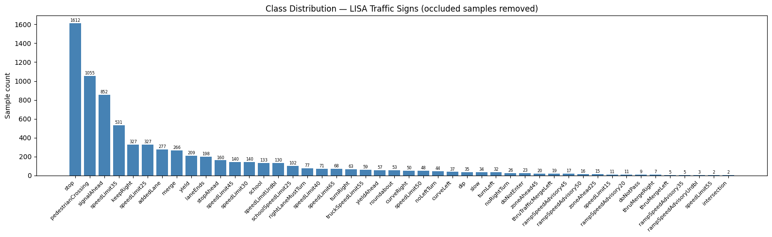
Figure 1: Class distribution after occlusion filtering (n = 7,387), showing class imbalance across 47 traffic sign categories before augmentation.

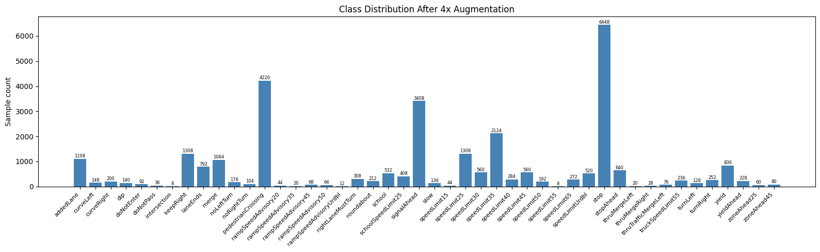
Figure 2: Class distribution after 4x augmentation (n = 29,512) across 47 traffic sign categories.

Methods
After data processing, we separated the data into a train/test split and built the twelve classification models. We do not hyperparameter tune any of the models or techniques used and typically opt for default parameters.

Train/Test Split
We applied an 80/20 train/test split to the data. Since we wanted each member to have the same data when training the models, we set a random state parameter. We also used the stratify parameter to ensure the training and test splits have the same proportion of classes as the original dataset [1] since our data is heavily imbalanced. After this, we applied synthetic minority oversampling technique (SMOTE) to oversample the imbalanced classes. Since the dataset contains signs with images in the single digits and others in the thousands, SMOTE would even the playing field so that the classifiers would not overfit for the signs that dominated [2].

Dimensionality Reduction and Data Visualization
We use three methods for dimensionality reduction and data visualization: principal component analysis (PCA), uniform manifold approximation and projection (UMAP), and t-distributed stochastic neighbor embedding (t-SNE).

The goal of PCA is to find a linear and orthogonal projection of the high dimensional data X to a low dimensional subspace such that the low dimensional subspace is a “good approximation” to the original data. Our image data is high dimensional since they vary in size from 640x480 to 1024x522. PCA works by finding the eigenvalues and eigenvectors of the covariance of the data and picking the top k eigenvectors (principal components) that explain some percent of the variance. We chose 95% as a standard. Figure 3 shows that we required 72 components in order to explain 95% of the variance. The data is then projected onto these 72 directions. By reducing the dimensionality of the data with PCA, we are able to train the classifiers for a shorter amount of time.

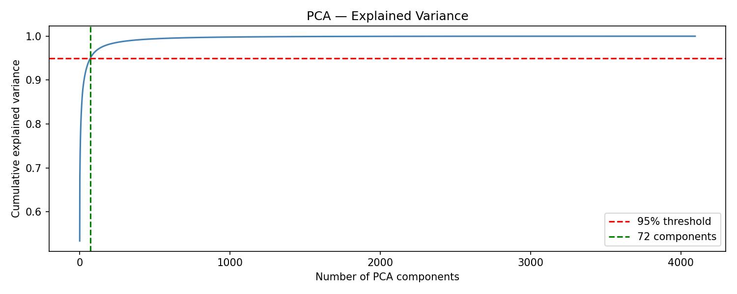
Figure 3: Graph showing the number of components required to explain 95% of the variance.

UMAP is a non-linear dimensionality reduction technique that preserves both the local and global structure of the data using graph theory and manifold learning. It creates a high-dimensional graph, then creates a low-dimensional graph that is structurally similar. UMAP is used when we want speed, cluster visualization, and scalability.

For our task, we set the number of components to 15, which keeps more structure for the classifiers to work with. This number is low enough to reduce noise but also high enough that we don’t lose important variation. We set the number of neighbors to the default, 15, but increasing it would provide a more global structure [3]. It would have been better to increase it for image classification since we usually want enough global structures to well-separate the classes. We set the minimum distance, which controls how tightly packed the points are, to 0.1 to create moderately tight clusters [3]. Figure 4 shows the visualization of the 2D embeddings created from the training set before applying SMOTE.

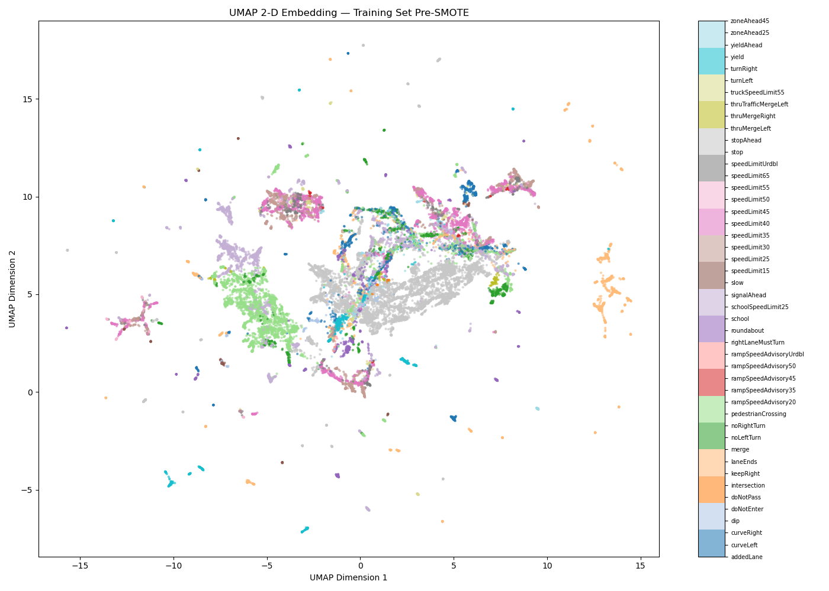
Figure 4: Graph showing the UMAP visualization in 2D space of the training set.

t-SNE is a data visualization technique that maps high dimensional data into 2D or 3D space by keeping similar points close together. It works by computing similarities between data points in high dimensional space, then model the low dimensional similarities with the Student-t distribution, and minimize divergence between the two. Figure 5 shows the visualization created for the 2D embedding on the training set before applying SMOTE. The embeddings were created based on the entire dataset, which makes the visualization more uniform.
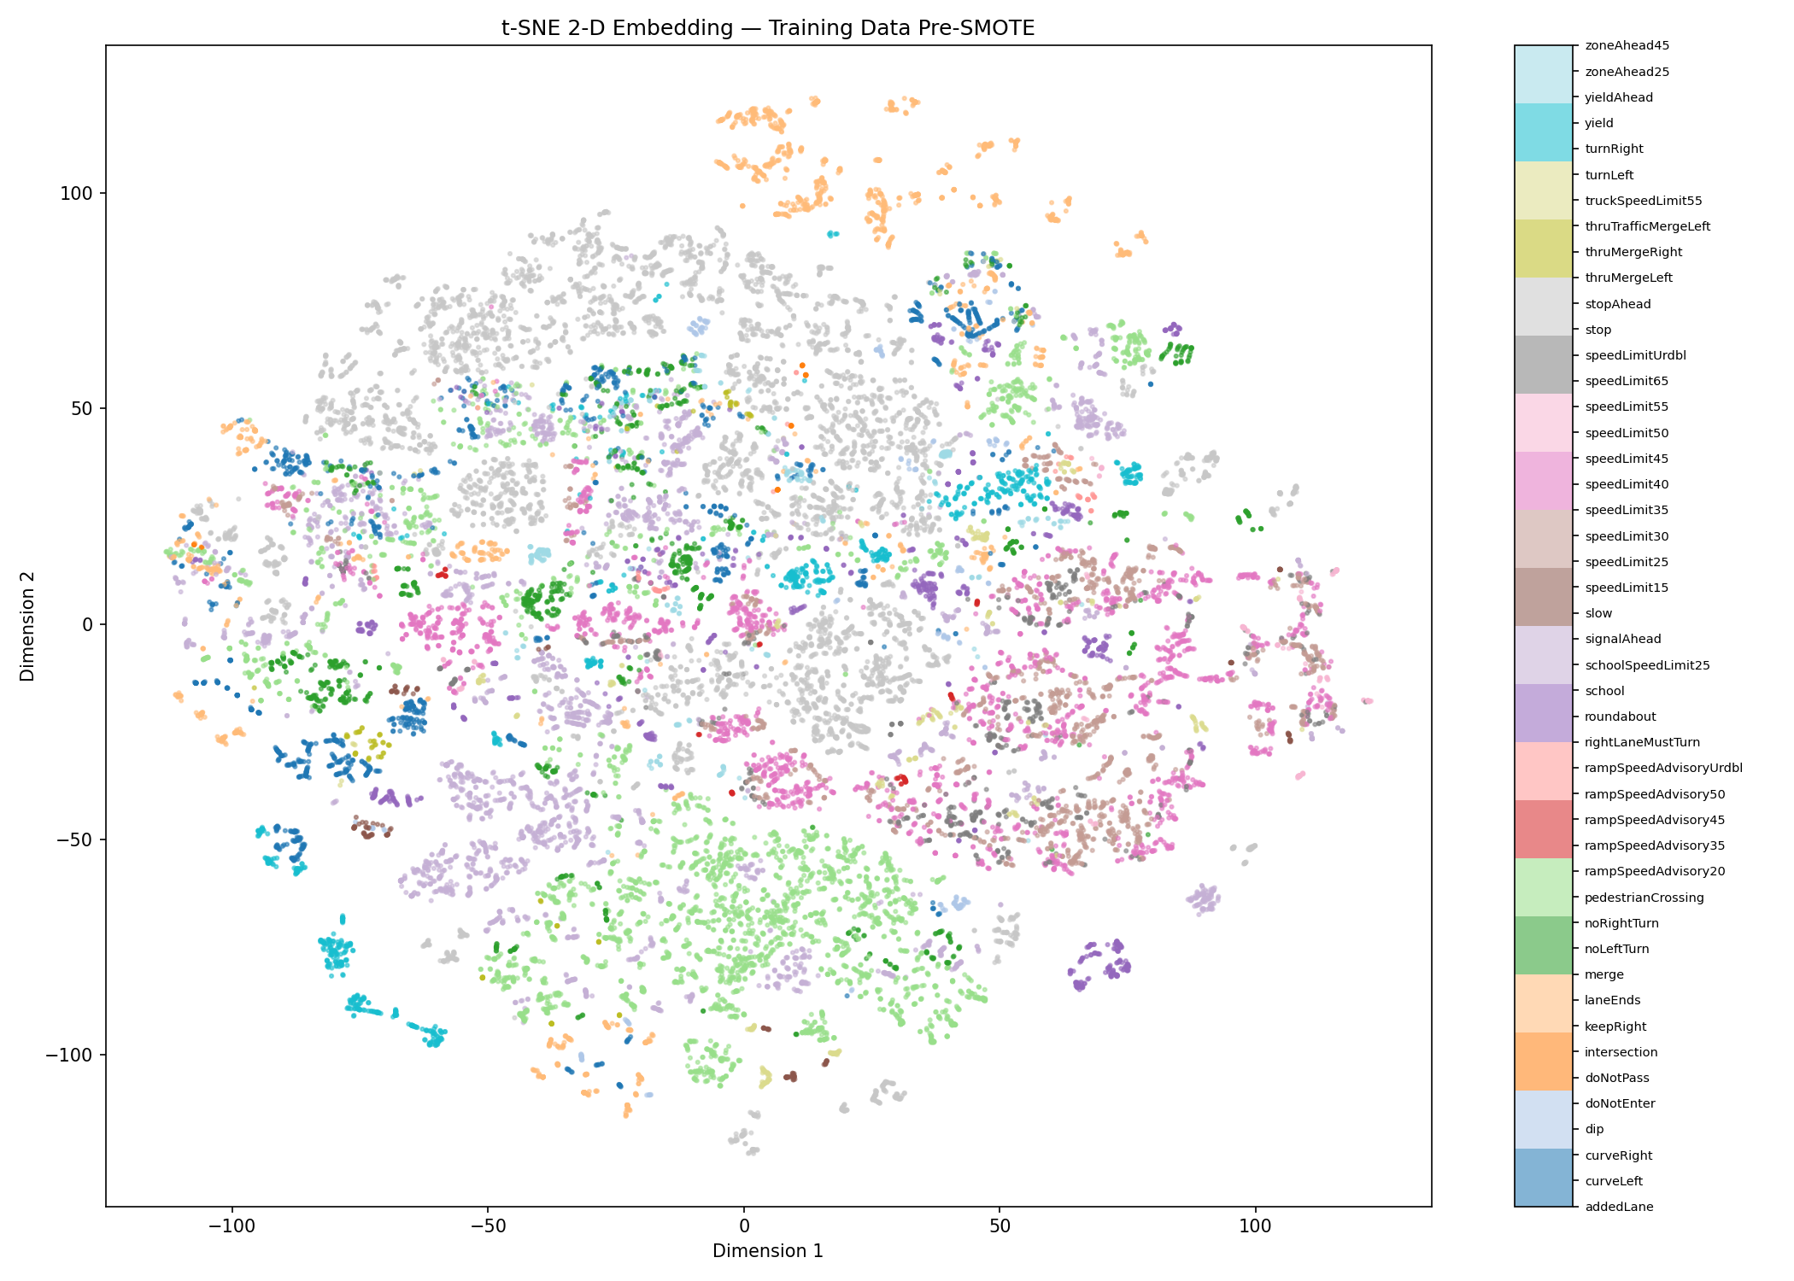
Figure 5: Graph showing the t-SNE visualization in 2D space of the training set.

To implement this, we first pre-reduced the dataset to 50 PCA dimensions, which is standard practice. This is done in order to speed up t-SNE. We set the number of components to 2 so that we could easily visualize the data in 2D space. We use the default perplexity value, 30, which is a good starting point, but should be tuned in the future.

Classification Models
The four classification models we use are Random Forest, XGBoost, Support Vector Machine, and Naive Bayes. We chose these models because we have seen them in other classes and wanted to pair them with dimensionality reduction techniques. We also wanted to showcase the advantages and limitations of the models on our specific dataset with PCA, UMAP, and t-SNE.

The Random Forest algorithm uses decision trees to make predictions. Decision trees are a tree-like structure that enable us to make decisions by showing how different outcomes are related [4]. They are composed of a root node, internal nodes, and end at a leaf node. The algorithm starts by asking a main yes/no question at the root node based on the dataset’s features [4]. It continues down different branches by following the ‘yes’ path until it reaches the leaf node [4]. Random Forest picks the majority class decided on by the multiple decision trees [5]. For our task, we decided to use 200 trees (double the default value) because it is large enough to work for classification without reduction and small enough to not be redundant with dimensionality reduction.

Random Forest has four assumptions: each tree makes a class prediction without influence, each tree uses random samples from the data, there needs to be a large amount of data, and combining predictions leads to a more accurate result [5].

The advantages of Random Forest are that it has very accurate predictions, performs well even with missing data, does not require normalization or standardization, and reduces the risk of model overfitting [5]. The disadvantages of Random Forest are that it can be computationally expensive and is less interpretable [5].

XGBoost combines weak models into a stronger model by iteratively improving on the weaknesses of the preceding model [6]. It starts by creating a decision tree trained on the data and calculates the error [6]. Then, it trains the next tree on the errors of the previous tree in an attempt to correct the former errors [6]. This process is repeated until some stopping criterion is met [6]. The final prediction is the summation of the predictions from all the trees created [6].

XGBoost works well because it uses different methods to reduce overfitting, such as penalizing overly complex trees, growing trees depth-wise, and controlling each tree’s contribution [6]. The tree structure allows it to handle complex feature interactions [6]. The sparsity-aware approach that it takes treats missing values as a separate category, which makes predictions robust even in the presence of missing data [6]. Additionally, it optimizes memory usage and can efficiently handle large datasets [6]. XGBoost is disadvantageous in that it can be computationally intensive, sensitive to outliers, and is not as interpretable [6]. For our task, we set the number of boosting rounds to 200 as a starting point. Since we decided not to hyperparameter tune, we left it at that. We set the evaluation metric to multiclass log loss since this is a multiclass classification problem.

Support Vector Machine attempts to find a hyperplane that best separates two classes in a set of data [7]. It does so by maximizing a separation margin between classes, a larger margin meaning better performance on unseen data [7]. The support vectors are the closest points to this hyperplane, which are the most important in determining both the hyperplane itself and its margins. The advantages of SVM are that it effectively handles nonlinear relationships, is memory efficient, has binary and multiclass support, is resistant to outliers, and excels in high-dimensional space [7], making it optimal for image classification, the main focus of this project. The limitations of SVM are that it is slow to train, noise sensitive, has limited interpretability, and is sensitive to feature scaling [7]. For our task, we chose the regularization parameter to be 10 as a starting point. We decided not to change it, leading to potential overfitting. We left the gamma at "scale," the default that scales gamma based on the number of features and their variance.

Naive Bayes uses Bayes' Theorem to classify data based on probabilities of different classes from our data [8]. It starts by calculating the likelihood, or the probability of a feature matrix appearing, given a particular response we are interested in. That likelihood, along with the probability that the response appears, is used to determine the posterior probability that the particular response, coupled with those features, is the true classification of that observation. The response that maximizes that posterior probability is then predicted by Naive Bayes to be the correct classification for that observation. Naive Bayes is advantageous because it is easy to compute and implement, effective in cases with a large number of features, and performs well even with limited training data. It is disadvantageous due to the fact that zero probability can be assigned to unseen events, leading to poor generalization, and irrelevant attributes may influence responses [8]. The main assumption of Naive Bayes is that all features are independent of each other. This assumption is broken in our case, since image data is generally always highly correlated.

Results
Evaluation Metrics
To evaluate the performance of each classification model, we reported three metrics: overall accuracy, balanced accuracy, and macro F1-score [10]. As our dataset contains significant class imbalance across 47 classes, even after applying augmentation and SMOTE, using overall accuracy alone can be misleading. A classifier that mainly predicted the majority class, such as stop signs (~22% of the augmented dataset), could achieve a deceptively high accuracy score while failing on rarer signs like intersection signs (0.03% of the dataset). Balanced accuracy and macro F1-score both penalize poor performance on minority classes and together give a more complete picture of model performance.

Overall accuracy is the proportion of correct predictions among all predictions made. Balanced accuracy averages each class's individual recall, weighting all classes equally regardless of size. Recall per class measures how many true instances of that class the model correctly identified.
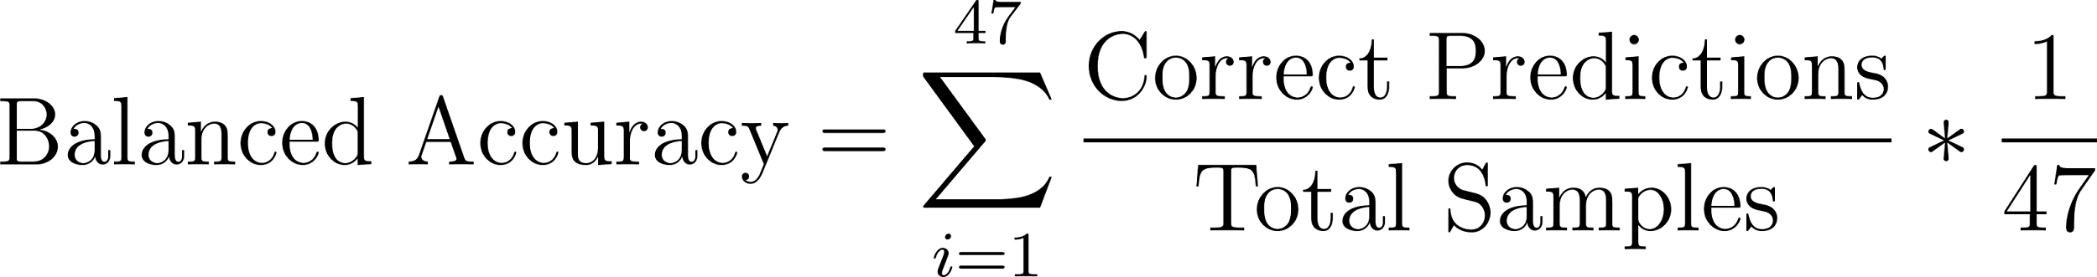

The macro F1-score incorporates both precision and recall into a single metric while treating all classes equally. Precision per class measures how often the model's positive predictions for that class are correct.

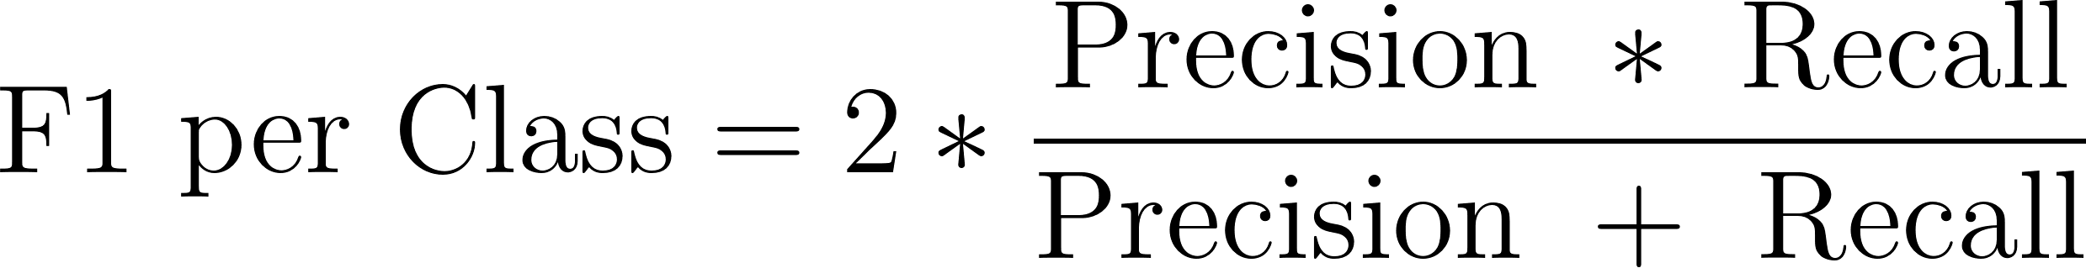


Overall accuracy reports raw correctness, balanced accuracy reflects whether the model finds each class, and macro F1 captures the trustworthiness of predictions. A strong model should perform well on all three.

Results by Dimensionality Reduction Technique
The twelve model combinations varied considerably in performance, summarized in Table 1 (Appendix).

PCA performed the best across all three dimensionality reduction techniques, achieving over 0.70 balanced accuracy with every classifier and exceeding 0.90 with three of the four. Its success is likely attributable to its preservation of a linear global structure. The projection retains the discriminative variance in traffic sign images that classifiers rely on to separate classes effectively.

UMAP produced moderate results, with balanced accuracies ranging from 0.34 (Naive Bayes) to 0.82 (Random Forest and XGBoost). The 15-component embedding we used, combined with the default neighbor setting of 15, likely emphasized local cluster structure at the expense of the broader class separation needed for classification. A higher component count and more neighbors would better preserve the global structure that classifiers depend on.

t-SNE produced the most inconsistent results. Paired with tree-based methods, it remained competitive, with Random Forest and XGBoost achieving balanced accuracies of 0.93 and 0.92, respectively. However, SVM and Naive Bayes performed poorly, dropping to 0.68 and 0.32. This is because t-SNE is primarily a visualization tool. It warps distances between points to produce visually distinct 2D clusters, which disrupts the structured feature space that SVM and Naive Bayes rely on. Tree-based methods are more tolerant of this distortion as they make decisions by splitting on feature thresholds rather than relying on distance.

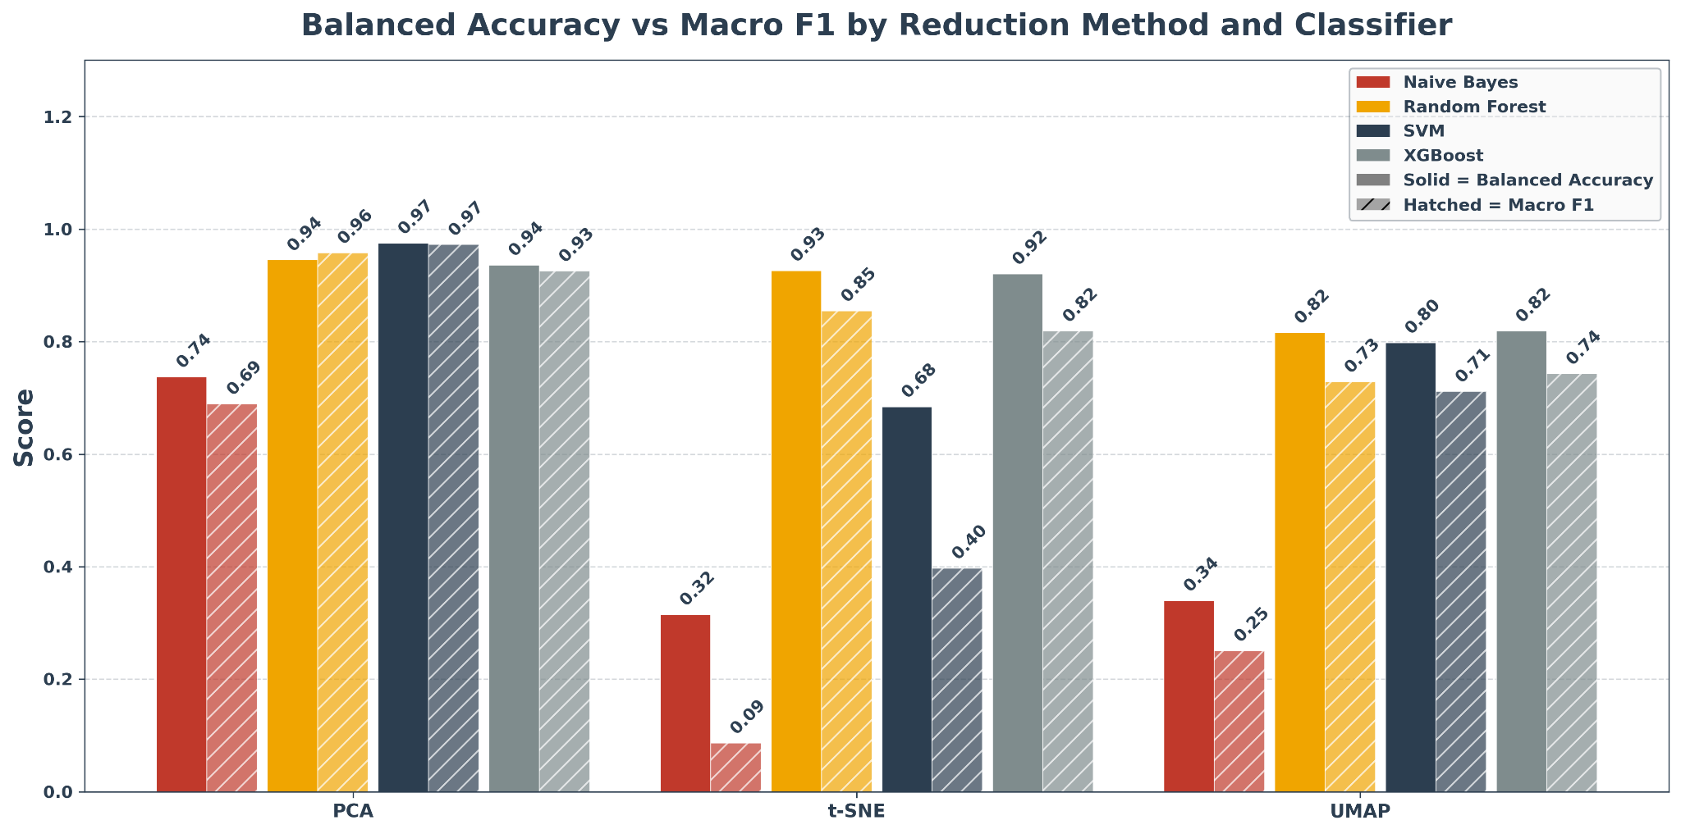
Figure 6: Graph showing balanced accuracy and macro F1-scores for twelve models. Classifiers coupled with PCA dimension reduction performed the best overall. Naive Bayes classifiers performed the worst regardless of the dimension reduction method.

Results by Classifier
Among the four classifiers, SVM achieved the highest balanced accuracy and macro F1 (0.975 and 0.972) when paired with PCA, making PCA + SVM the best overall model. This combination benefits from PCA's compact, linearly structured feature space, which allows SVM to identify a clear separating hyperplane across all 47 sign classes. The high balanced accuracy confirms that it generalizes well even to minority classes. However, SVM's performance degraded significantly with noisier embeddings, dropping to 0.68 balanced accuracy with t-SNE and 0.80 with UMAP, reflecting its well-known sensitivity to the geometry of the input space.

Random Forest and XGBoost were the most consistent classifiers across all three reduction techniques. With PCA, Random Forest achieved 0.945 balanced accuracy (macro F1 = 0.957) and XGBoost achieved 0.936 (macro F1 = 0.925). Both held up well with t-SNE at 0.926 and 0.920, respectively, and were nearly identical with UMAP at 0.816 and 0.819. Neither method relies on distance geometry or feature independence and is thus more tolerant to the distortions introduced by UMAP and t-SNE than SVM or Naive Bayes. A closer look at balanced accuracy versus macro F1 reveals that with PCA, the two metrics are closely aligned for both classifiers, suggesting precision and recall are well balanced in a high-quality embedding. With t-SNE and UMAP, however, a gap of 0.07–0.10 indicates that while the models continue to recall a reasonable proportion of each class, they generate more false positive predictions as class boundaries become less distinct in noisier embeddings.

Naive Bayes was the weakest classifier across all three techniques, which is expected given that it assumes all features are conditionally independent. This assumption is strongly violated in image data where neighboring pixels are inherently correlated. Even with PCA's 72-component representation, it achieved only 0.737 balanced accuracy and the lowest macro F1 of any PCA-based model at 0.689. With t-SNE and UMAP, the results were worse still. Balanced accuracy fell to 0.315 and 0.340. The gap between balanced accuracy and macro F1 was larger for Naive Bayes than for any other classifier; with t-SNE, the gap of 0.229 indicates the model's predictions were so imprecise that it was largely guessing.

Conclusion
Through this project, we applied classical machine learning techniques to classify traffic signs using the LISA Traffic Sign Dataset, pairing four classifiers (Naive Bayes, Random Forest, XGBoost, and SVM) with three dimensionality reduction methods (PCA, UMAP, and t-SNE) and evaluating performance through overall accuracy, balanced accuracy, and macro F1. Across all twelve combinations, PCA proved to be the most effective dimensionality reduction method, attributable to its preservation of linear global structure that classifiers rely on to separate classes. UMAP produced moderate results, and t-SNE’s results were widely ranged. Both performed well with ensemble tree methods, but failed when paired with SVM and Naive Bayes. Among classifiers, Random Forest and XGBoost were the most robust across all three embeddings, SVM's strong performance was largely dependent on embedding quality, and Naive Bayes consistently underperformed due to its violated independence assumption. The best overall model was PCA + SVM, achieving 0.987 accuracy, 0.975 balanced accuracy, and 0.972 macro F1.

Limitations and Extensions
Several limitations of our approach are worth acknowledging. All models were run with default hyperparameters, and no tuning was performed, which likely disadvantaged parameter-sensitive methods like SVM and XGBoost. Notably, for SVM, we left the regularization parameter at the default C =10, which may have produced inflated accuracy results by allowing model overfitting. Grayscaling during preprocessing removed all color information, potentially discarding discriminative features for sign categories where color is meaningful. Our single 80/20 train/test split without cross-validation may not fully represent how models generalize to unseen data, particularly for underrepresented classes.

As extensions to our work, hyperparameter tuning for SVM, XGBoost, and the UMAP embedding parameters would likely close the performance gap between weaker and stronger combinations. For SVM specifically, tuning the value of C may produce more representative results. Restoring color by working in RGB or HSV space rather than grayscale could improve performance across all methods. Replacing the single train/test split with k-fold cross-validation would provide more reliable performance estimates. Linear Discriminant Analysis (LDA) would be an interesting alternative to PCA to explore, as it incorporates class label information during reduction and may produce a more discriminative embedding. Finally, comparing our best result against a CNN baseline would provide useful context for how much performance remains on the table when restricting to classical methods.

Sources

- UCSD, “LISA Traffic Sign Dataset.” Accessed: May 10, 2026. [Online]. Available: https://git-disl.github.io/GTDLBench/datasets/lisa_traffic_sign_dataset/
- G. Bradski, "The OpenCV Library,"Dr. Dobb's Journal of Software Tools, 2000.
- “lmcinnes/umap: Uniform Manifold Approximation and Projection.” Accessed: May 10, 2026. [Online]. Available: https://github.com/lmcinnes/umap
- “Decision Tree in Machine Learning,” GeeksforGeeks. Accessed: May 10, 2026. [Online]. Available: https://www.geeksforgeeks.org/machine-learning/decision-tree-introduction-example/
- “Random Forest Algorithm in Machine Learning - GeeksforGeeks.” Accessed: May 10, 2026. [Online]. Available: https://www.geeksforgeeks.org/machine-learning/random-forest-algorithm-in-machine-learning/
- “XGBoost,” GeeksforGeeks. Accessed: May 10, 2026. [Online]. Available: https://www.geeksforgeeks.org/machine-learning/xgboost/
- “Support Vector Machine (SVM) Algorithm,” GeeksforGeeks. Accessed: May 10, 2026. [Online]. Available: https://www.geeksforgeeks.org/machine-learning/support-vector-machine-algorithm/
- “Naive Bayes Classifiers,” GeeksforGeeks. Accessed: May 10, 2026. [Online]. Available: https://www.geeksforgeeks.org/machine-learning/naive-bayes-classifiers/
- M. Grandini, E. Bagli, and G. Visani, “Metrics for Multi-Class Classification: an Overview,” arXiv:2008.05756 [cs, stat], Aug. 2020, Available: https://arxiv.org/abs/2008.05756
- Python Software Foundation, "Python Programming Language." Accessed: May 10, 2026. [Online]. Available: https://www.python.org
- F. Pedregosa et al., "Scikit-learn: Machine Learning in Python," Journal of Machine Learning Research, vol. 12, pp. 2825–2830, Oct. 2011.
- P. Song, “Cross Validation Strategies for Imbalanced Datasets,” ML Journey. Accessed: May 10, 2026. [Online]. Available:

Appendix
